|  |  |  |  |  |  |  |  |  |
| --- | --- | --- | --- | --- | --- | --- | --- | --- |
|  | | | | | | | | |
|  | | **PF Sense Open-Source Firewall configuration lab** | | | | |  | |
|  |  | | | | | | |  |
|  | | | |  |  | | | |
|  | | | | Weizhen Chen |  | | | |
|  | | | | —CCNP—Jeffery Mason &Michael Hansen |  | | | |
|  | | |  | | |  | | |

Purpose

The Purpose of the lab was to set up a PF Sense firewall, with port forwarding that would forward RDP traffic from the outside network to a computer that’s locally connected to the firewall’s network.

Background information

NetGate PF Sense is an open-source firewall/router operating system based on FreeBSD created by Rubicon Communications. It can be installed onto a computer, or on a virtual machine. And has features such as DHCP, NAT, Port forwarding, and other things that a normal firewall and router would have. Which can be configured by a console or have it setup in a web console that can be easily accessed from a web browser. FreeBSD is a free open-source Unix-Like operating system from the Berkeley Software Distribution and is based on Research Unix. It was originally released in 1993, and in 2005 it was the most popular open-source BSD operating system. Rufus is a free and open-source portable application for Microsoft Windows. Which is used to format external USB Drives, and image them to create bootable flash drives or live USBs to install operating systems onto a computer. Port Forwarding is an application of Network Address Translation or NAT, that would redirect a communication request from one IP address and port number to another. Which would be set up on a router or firewall, to allow things such as RDP, SSH, and other protocols to be sent to a specific device on an internal network that is coming from an external network. NAT or Network Address Translation is a method of mapping an IP Address or host into another by modifying the network address information in the IP header of packets, while being sent across a traffic routing device such as a firewall or router. RDP or Remote Desktop Protocol is a proprietary protocol developed by Microsoft which allows a user with a Graphical User Interface to connect to another computer in a network. The user connecting to the computer would need to have a RDP client to access the computer. And the target host needs to have an RDP server, so that RDP clients can have remote desktop access to the target host.

Lab summary/Configurations

In order to set up the PF Sense firewall we first need to install PF Sense onto a laptop, using a bootable USB drive that has the PF Sense installer imaged onto the USB drive.

We First Downloaded PF Sense Installer ISO :

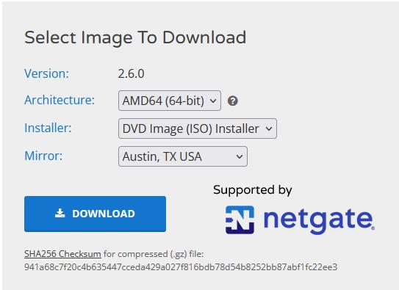

Next, We Downloaded Rufus USB imager:

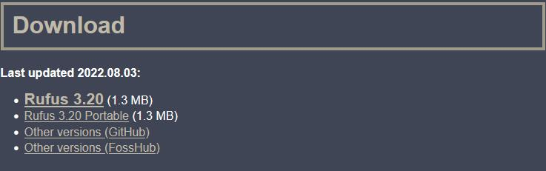

Next, We Used Rufus to Image the USB Drive:

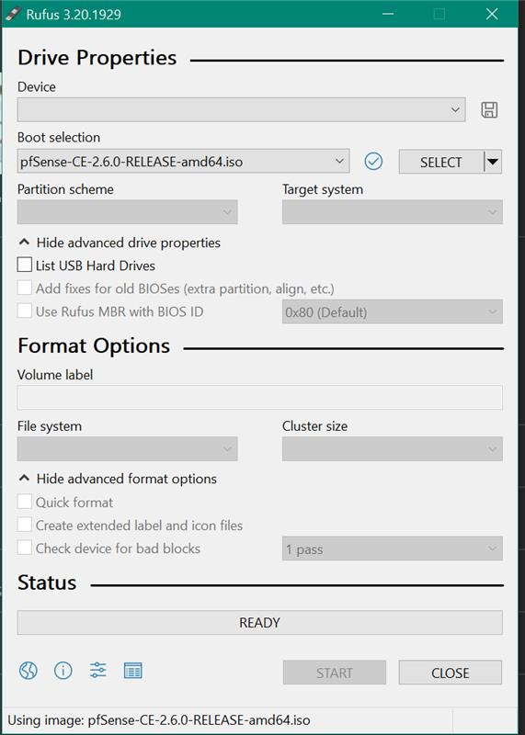

We Then Installed and Setup PF Sense On the Laptop

Opened Web Console:

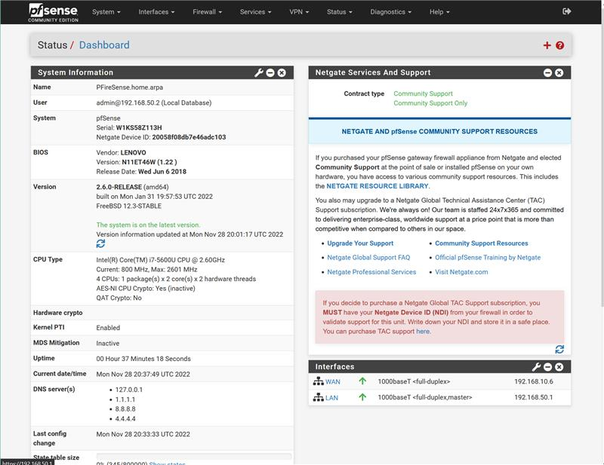

We Configured Port Forwarding using the Web Consle

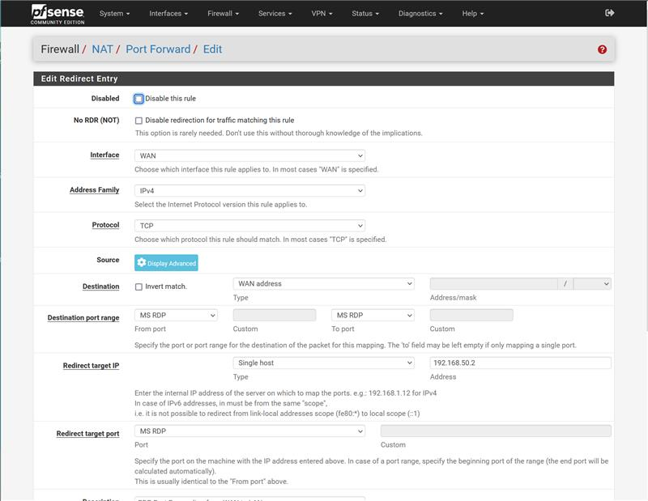

Problems

We have not encountered any major problems while configuring the lab. But we did encounter some small mistakes that stopped our progress. First, we had a problem with the PF Sense firewall not being able to forward RDP traffic from the WAN interface to the LAN interface. When comparing with what other people had set up, there was nothing that was misconfigured. This issue was resolved by changing the Filter Rule Association from “Add associated filter rule” or “Add unassociated filter rule” to “pass”. By Setting it to “Pass” it seemed to allow port forwarding from the WAN Network to the host connected to the LAN interface.

Conclusion

The Objective of the lab was to set up a PF Sense firewall, with port forwarding that would allow forwarding RDP traffic from the outside network to a computer that’s locally connected to the firewall’s network. During this prosses we learned how to set up an PF Sense firewall using a USB drive. During the lab we encountered some small troubles that we learned from. Ultimately, we were able learn to setup a computer on the WAN network to remotely connect to a device in the LAN network with RDP.